University of Engineering and Technology, Lahore
Name: Maria Abbas
Reg No: 2026(S) CYS_61
Department: Computer Engineering
Degree: Cyber security
Section: B
Assignment: PF Lab week 10
Date: 18 May 2026
CLO2

Lab Tasks
Recursion
Task 1:
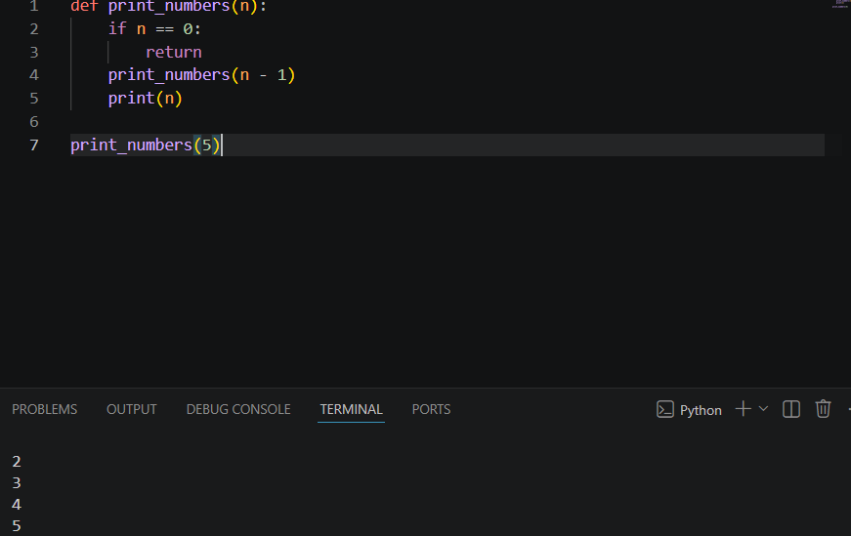
Task 2:
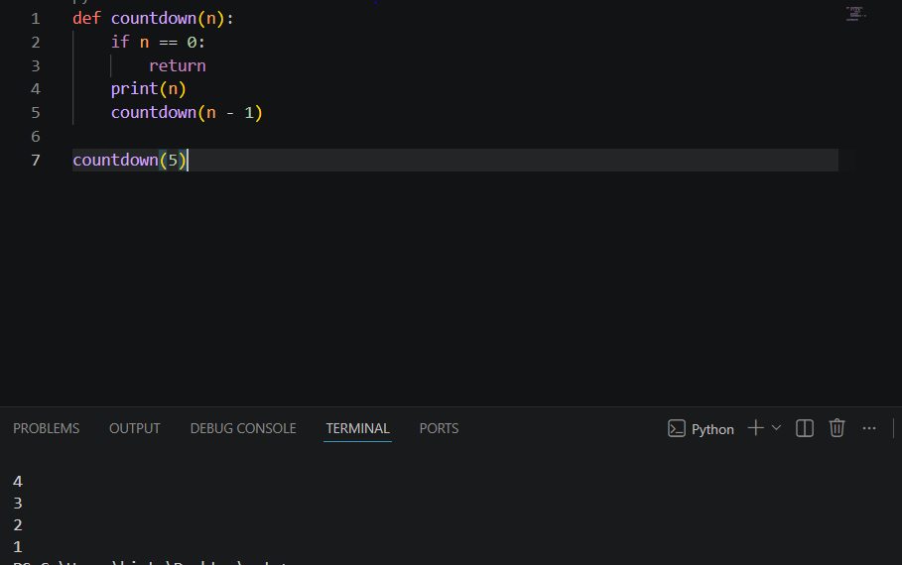

Task 3:
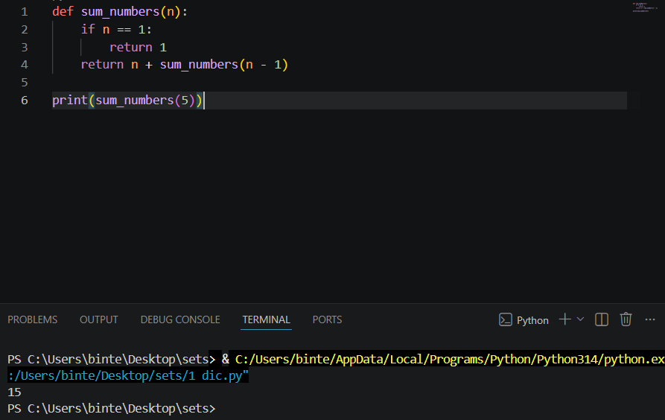

Task 4:
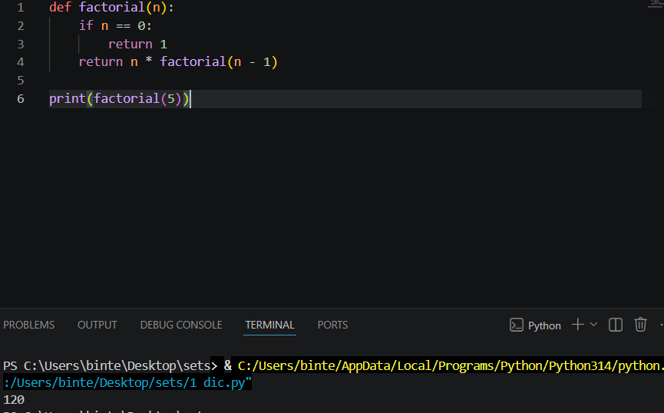

Task 5:
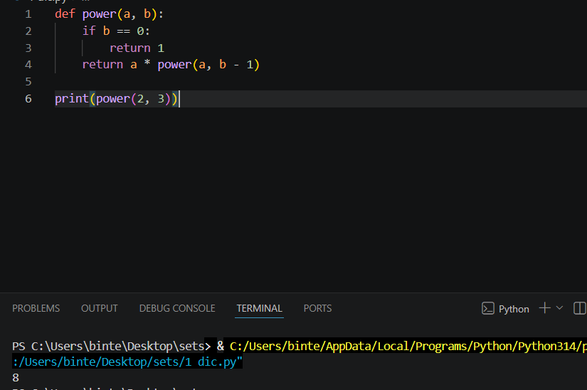

Task 6:
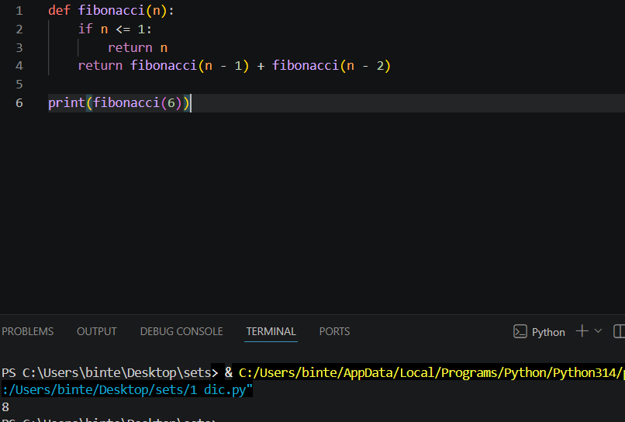

Task 7:
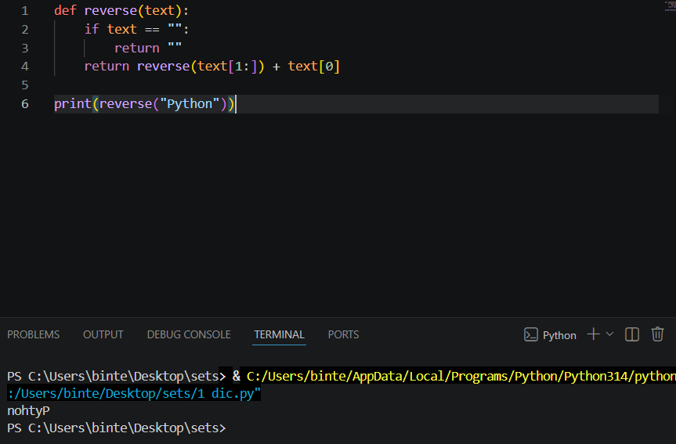
Task8:
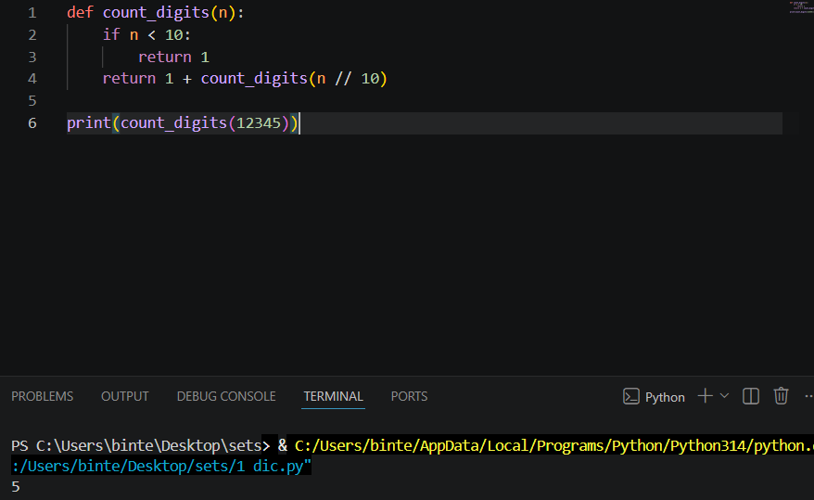
Task 9:
